3. Industry and Technology Landscape Analysis
3.1 Current State Assessment: As-Is Analysis
Faz Australia Flagship product is MedTalk. MedTalk is an artificial intelligence clinical documentation that listens to doctor-patient consultation producing a live transcription during the consultation. MedTalk connects to clinical systems or Best Practice (BP) where the completed EMR (electronic medical record) is stored and shared to other systems exposing integration interfaces via FHIR (Fast Healthcare Interoperability Resources). Halo Connect handles transformation of FHIR data to underlying systems formats. The EMR is coded using SNOMED CT-AU (Systematized Nomenclature of Medicine – Clinical Terms – Australian Extension) which is the Australian standard of comprehensive clinical vocabulary used in electronic health records. The EMR coded with SNOMED CT-AU is then mapped ICD-10-AM (International Statistical Classification of Diseases and Related Health Problems, Tenth Revision, Australian Modification) using MedTalk Internal Infrastructure. For billing purposes MedTalk partners with MediBetter BOSS (Billing Optimisation and Support Software) by sharing the translated ICD-10-AM to be mapped to the MBS (Medicare Benefits Schedule) system (MediBetter, 2026).

Faz Australia also utilise the HL7 FHIR R5 (Fast Healthcare Interoperability Resources) and SMART on FHIR protocols to test, map and synchronise data to the BPs exact data architecture that it is being integrated to (MedTalk AI, 2020). One of the developing platforms that MedTalk uses is Epic. Epic sandbox provides platform for developers to test integration first using mock patient data before EHR (Electronic Health Records) exchange. According to Choudhary (2026), for a company to upload their application on Epic is split into three main categories for charging fees. There is Connection Hub listing fee approximately USD$500, vendor services membership charging up to USD$1 900 and build Labour ranging from USD$40000 for read only FHIR and USD$350000 for full bidirectional (Choudhary, 2026). MedTalk and MediBetter partnership tech-tech API prices are not publicly available but according to MarkiTech.AI (2025), a flat fee ranges from $100 to $500. This excludes the subscription of the MediBetter professional suite which unlocks the BOSS engine and browser extensions for clinical workflow. These integration and subscription costs represent a significant financial pain point for MedTalk, focusing on the high upfront investment required for full bidirectional FHIR integration with Epic. These costs burden the scalability of Medtalk.

Apart from the financial burden on Faz Australia, the main operational inefficiency is lack of a reusable safe test environment. The restricted access to sandboxes slows development and harder to reproduce issues consistently to improve MedTalk overall. Due to strong privacy and compliance requirements, there is also limited flexibility in testing live connection with other BPs since Epic requires the application to be load on first to test it. These limitations clearly indicate the business pain on high costs in expansion, delayed integration tests and higher compliance exposure if problems are found late. These pain points are affecting engineering efficiency and confidence in releases, which this project of a test harness is designed to solve.
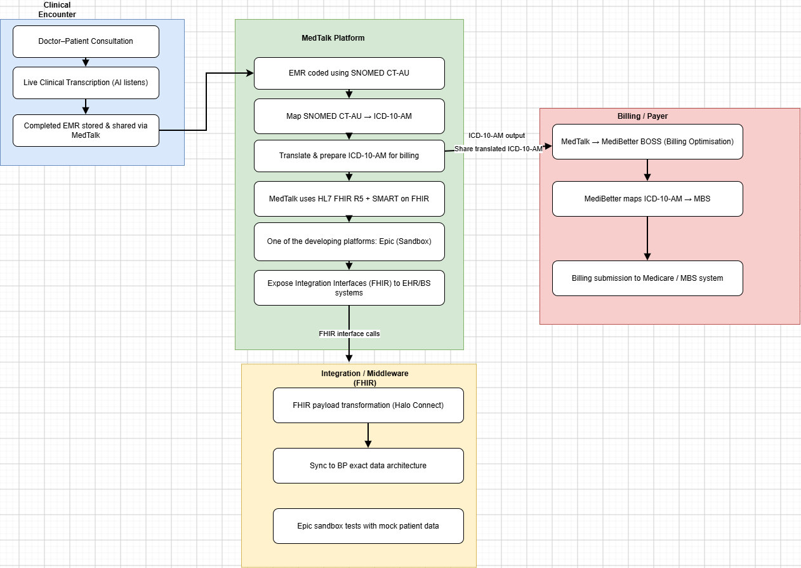

I have diagram

3.2 Technology & Market Survey
MedTalk is part of the Australian health interoperability market. The main technical challenge in this market is not only generating accurate clinical notes but safe exchange of the clinical notes and correct translation of the data to the receiving system. The most relevant technologies for the test harness are HL7 FHIR, SMART, vendor integration layers and Australian clinical terminology. These are all essential for the project as it has to reflect the same standards as production systems.

FHIR (Fast Healthcare Interoperability Resources) is the central exchange standard that defines resources meaning patient data, appointments, clinical notes and related information structure and transferred between systems (eCQI, 2025). It also depicts interaction patterns including real time representation state Transfer (RESTful) application programming interfaces (APIs), document based and messaging. The RESTful APIS use HTTP operations to create, read, update and search for FHIR resources to enable real time data exchange. FHIR framework is free to build commercial and open-source tools while HL7 is registered trademark that cannot be used without permission. FHIR is a necessity for the project to mimic structured clinical document exchange and be able to test it.

Australian clinical terminology and classification is vital which include SNOMED CT-AU and ICD-10-AM. SNOMED CT-AU is the preferred clinical terminology in Australia which is an extension of the global SNOMED CT standard. It combines international core clinical data with Australian-specific terms, spellings, local reference sets and the Australian Medicines Terminology (AMT). SNOMED CT-AU contains numerous clinical concepts organized into hierarchies like body structures, procedures and clinical findings. SNOMED CT-AU is then mapped to ICD-10-AM which is classification of diseases and diagnosis tailored to match Australian clinical terminology, practice and health-tracking need. The ICD-10-AM is mapped to MBS for billing in Australia. These terms need to be coded in the synthetic patient record correctly as the test harness will validate them. These terminologies are free access to code in synthetic data.

Synthea is currently one of the most credited synthetic patient generator as it creates realistic realistic mock medical histories and electronic health records lifespan from birth to death. Synthea is an open source but produces mock patients based on Unites States of America demographics. CSIRO have created Australian mock data using Australian demographics, but the synthea tool is not available for public. The mock data is available which would be used for this project to ensure compliance and mimics real clinical system. SMART on FHIR is the authentication and authorising secure system that lets third-party health apps log users in, access electronic health record (EHR) data using standard OAuth 2.0 protocols. This security is necessary to ensure that there is no authorised access to the Test harness.

Vendor integration layers include Halo connect to be implemented in the project. Halo connect is an Australian healthcare platform that safely links local medical practice systems to cloud-based software. It has two main components Halo Link and Halo Cloud. Halo Link is used to link the database to Halo cloud and Halo Cloud would be required for sharing data using standard formats like SQL and FHIR with approved external software. This integration is necessary as when the integration (another system) requires data from the server’s database, it sends this enquiry to the Halo Cloud then forwards it to the Halo Link agent. The agent sends the enquiry to the local system database and run the query and send back results.

The main gap in the current market is that existing standards and vendors solve only part of the problem. Standards define how data should be exchanged, vendor products expose endpoints and terminology systems define how meaning should be coded. This still then requires a synthetic test harness that utilises all these tools, standards and frameworks to form a repeatable automation testing, failure simulation and validation of edge cases.

3.3 Comparative Analysis of Existing Solutions
Technology | Core Functionality | Deployment Model | Limitations | Relevance to project
SMART Health IT Sandbox | Provides simulated EHR environ for testing HL7 FHIR APIs and OAuth 2.0 authentication and patient data exchange (SMART on FHIR, n.d.). | Cloud based sandbox | Testing in the sandbox does not guarantee compatibility with HER implementation | Partly relevant test FHIR interoperability and SMART on FHIR.
Epic on Epic App Orchard | Developer ecosystem for building and distributing applications that integrate with Epic EHR. Provides APIs based on HL7 FHIR, testing environments, documentation and integration capabilities (Bonami Software, 2026). | Cloud/EHR integrated | Integration can involve significant development, certification and commercial costs.  Access is to production data and APIs is restricted. | Relevant but does not validate the terminology.
MediRecords Developer Sandbox | Provides developers with an environment to test applications and integrations with MediRecords (MediRecords Connect, 2026) | Cloud based developer sandbox | Sandbox data and functionality may differ from the production environment. | Moderately Relevant but does not validate the terminology.
Synapxe HealthX innovation sanbox | Provides an innovation and experimentation environment for healthcare technologies, supporting testing, prototyping and validation of digital health solutions and interoperability concepts within a healthcare ecosystem (Synapxe, 2023) | Innovation sandbox/ testing environment | Primarily focused on Singapore’s healthcare ecosystem different from Australian. | Moderately relevant as a reference model for testing healthcare technologies

The comparison of existing healthcare sandbox platforms demonstrates that solutions such as
SMART Health IT Sandbox, Epic on Epic App Orchard, Medi Records Developer Sandbox and Synapxe HealthX innovation sandbox provide valuable environments for testing interoperability. Each solution has its limitations in scope of either accessibility or platform dependency. These environments are primarily designed around specific HER ecosystems or organisational requirements rather than providing a vendor neutral solution for comprehensive healthcare integration testing. Medtalk requires an effective test harness that extends beyond basic API connectivity, validation of accurate data exchange and interpretation across the different healthcare systems. This includes validating terminology to ensure that clinical concepts retain their intended meaning between different systems. The proposed Test Harness would be a centralised and independent harness that allows integration of workflows, FHIR resources, authentication, data mapping and terminology validation to be tested before and after production deployment. The harness would reduce reliance on many vendors for testing multiple components.

3.4 Gap Analysis:
The test harness would address a challenge which includes unsafe or restricted testing versus a reusable fully synthetic test environment. In the current state Medtalk rely on partners, restricted or manual testing to validate integrations. That creates privacy, high financial costs and operational risk because real patient data cannot be used to test during live production. The proposed solution closes this gap by creating a complete (100%) synthetic system that MedTalk connects to, to ensure that all testing occurs without exposing real patient records.

The second gap is basic API connectivity as to standard aligned interoperability. A system can technically send or receive data but still fail to meet Australian expectations if it does not align FHIR, SNOMED CT-AU and ICT-10-AM. This could result in rejected messages and incorrect information shared. The proposed harness address this explicitly by mapping what MedTalk sends and receives using FHIR standard making integration behavior testable and reusable.

The third gap is clinical text generation as to code clinical meaning. MedTalk does not only document doctor patient conversation, but it must also support structured output that can be coded using SNOMED CT-AU and translated where necessary into ICD-10-AM for MBS. The existing integration approach does not provide an independently verification mechanism for consistently detecting semantics that are mismatches or dropped between the layers. The proposed dataset will close this gap by using synthetic records with known terminology mapping and checking the translation outcomes.

The fourth gap is happy path testing as to resilience testing. In real world healthcare integrations fail because of delays, malformed payloads, dropped connections and incomplete data. If failure conditions are not tested before deployment, MedTalk may behave unpredictably when connected to external systems like failed transactions. This requires a testing environment that does repeatable error simulations. The test harness will test robustness by simulating slow systems, bad data and connection loss.

The fifth gap is manual validation as to reusable automation testing. When there is no automation, each release requires human checks which is slow and prone to errors. The proposed solution introduces automatic test suite, making it easy to repeat scenarios, compare results and identify regression. This boosts engineering efficiency and release confidence.

The final gap is fragmented tooling as to a single validation workflow. Existing standards, terminology mapping and vendor interfaces each solve a separate problem, while MedTalk requires a unified controlled environment that brings them all together. Fragmented testing increases complexity and makes it difficult to establish consistent validation process. The proposed test harness closes this gap by merging standards-based messaging, terminology validation and performing automated testing.

References
eCQI. (2025). FHIR® - Fast Healthcare Interoperability Resources® - About | eCQI Resource Center. Healthit.Gov. https://ecqi.healthit.gov/fhir/about

For practices - Halo Connect Documentation. (2026). Haloconnect.Io. https://docs.haloconnect.io/guides/practice-guide/

MedTalk AI. (2020). AI Medical Scribe Features in Australia. MedTalk AI. https://medtalk.co/au/product

MediBetter | Integrations. (2026). Medibetter.Com.Au. https://medibetter.com.au/ integrations/

MarkiTech.AI. (2025, ). MarkiTech. https://markitech.ca/our-work-healthcare/ accessed 09 September 2026.
Choudhary, J. (2026). How to Get Your App Into Epic (2026). Nirmitee.Io. https://nirmitee.io/blog/how-to-get-your-app-into-epic/

SNOMED CT-AU and Australian Medicines Terminology May 2022 Release. (2022). Digitalhealth.Gov.Au. https://www.digitalhealth.gov.au/healthcare-providers/product-releases/snomed-ct-au-and-australian-medicines-terminology-may-2022-release

SMART on FHIR. (n.d.). Docs.Smarthealthit.Org. Retrieved September 11, 2026, from https://docs.smarthealthit.org/

Bonami Software. (2026). Epic Integration & Implementation. Bonami Software. https://www.bonamisoftware.com/epic-integration

MediRecords Connect: Getting Started with Connect & FHIR APIs. (2026). Knowledge Base. https://support.medirecords.com/hc/en-us/articles/13936381648399-MediRecords-Connect-Getting-Started-with-Connect-FHIR-APIs

Synapxe - HealthX Innovation Sandbox. (2023). Healthx.Sg. https://innovation.healthx.sg/

